Meet the Office Team!!

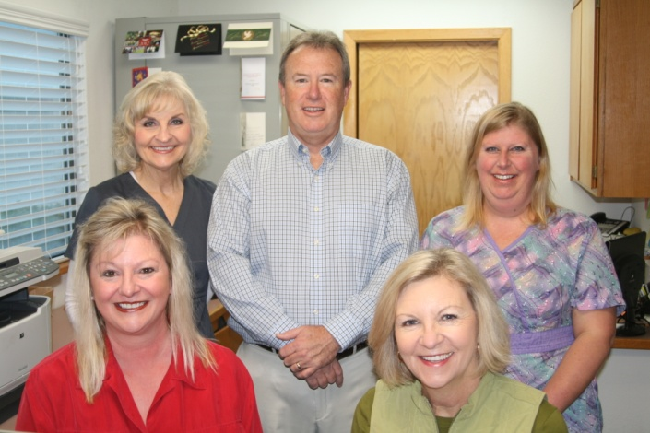

STAFF

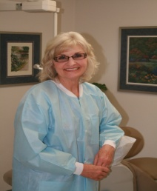

Gail Starling RDH: Dental Hygienist

Gail is a graduate of Fresno State College with a B.S. degree in Health Science and also a graduate of Fresno City College with A RDH license in Dental Hygiene. She practiced as a Registered Dental Hygienist in a Fresno periodontics office for 15 years before beginning her career at Dr. Wilburn’s office in Santa Rosa in 1991.
Gail is an active member of the Redwood Chapter of the California Dental Hygienists Association and has been an integral part of Dr. Wilburn’s practice for 21 years.
She is very compassionate and dedicated to both her patients and fellow staff. She states that she loves the professional opportunities Dr. Wilburn’s practice allows her in professional growth and development. When asked about her priorities as a hygienist she states: “I believe in treating each individual as a person first and a patient second. My goal is to create a relationship on which trust is the basis. I strive to keep our patients informed about their periodontal health, its relationship to their general health and to instruct and educate each patient about their oral hygiene. I love the opportunities that Dr. Wilburn’s practice affords in promoting these goals”.
Gail lives in Windsor with her husband Gary. They have three grown children and 3 grandchildren who all live in the nearby area. When not working, Gail enjoys capturing special family time, walking, hiking, cooking, crafts, and is very active in assisting in her church’s activities. We are very proud to have Gail as part of Dr. Wilburn’s staff.

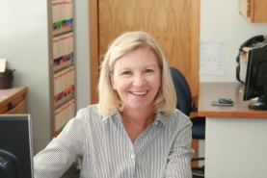

Janey Christensen: Office Manager

Janey was born and raised in Petaluma and moved to Santa Rosa in 1976. She graduated from the Santa Rosa Junior College with a degree from the Dental Assisting Program. She has worked at Dr. Wilburn’s office for 21 years, starting out as front office receptionist and assistant, and later transitioning to the Office Manager position.
Janey enjoys working in Dr. Wilburn’s office and is quick to add: “Our patients are like family to us!” Patients can’t help but notice her easy going yet professional manner. It is easy to see how she makes each and every patient feel welcome and “a part of the office family”. She is a vital part of the practice… ensuring the office runs smoothly and efficiently.
Janey has been married to her husband Mark for 40 years and has three grown children. They are also very blessed to have two grandchildren.
Her hobbies include travel, reading, and exercising. She recently ran her first half -marathon and hiked to the top of Half Dome in Yosemite!! We feel very, very fortunate to have Janey as part of Dr. Wilburn’s staff.

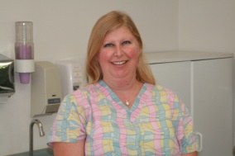

Karre-Ann Wilke RDA: Dental Assistant

Karre-Ann was born in Petaluma. She attended Rosa Junior College and continued her training at Bryman Dental Assisting School in San Francisco. She received her Registered Dental Assistant license in 1998. She has been our office RDA for ten years now and on occasion, will help in the front office. As Dr. Wilburn’s assistant, Karre-Ann is more than an extra set of hands…. Her gentle approach to assisting, her equally gentle X-ray technique and her warm personality are sure to make the patients feel at ease in the chair. Her personality is as sparkly as her bright blue eyes and she always turns a trip to the dentist into a pleasant encounter with a friend.
Karre-Ann lives in Rohnert Park with her spouse, Felicia Younger, and now lives directly next door to the elementary school she attended as a child! Her love of Sonoma County is indeed evident with her desire to stay so close to her roots!! She is the mother of two children and has recently become a proud grandmother. She is sure to make your visit to Dr. Wilburn’s office a pleasant one.
We feel very lucky to have Karre-Ann as our main back-office assistant and occasional front desk assistant.

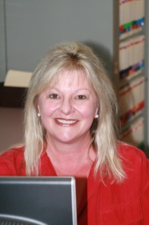

Suzanne Sciucchetti: Front Office and Chair-side Assistant

Suzanne was born and raised in Healdsburg and began her career as a dental assistant in 1979 with Dr. Tom Conklin (ret.). Later she transitioned to a front office position in 1986 for Dr. Clint Weaver in Santa Rosa. She joined Dr. Wilburn’s team in 2006 and currently works part time in the front office and on occasion will also assist chair-side.
Suzanne lives in Cloverdale with her long-time companion Randy and has two grown children and 2 grandchildren. Her hobbies include cooking, reading and gardening. Of course, she also especially enjoys time with her grandchildren .
Suzanne has a quick smile and a caring approach while tending to each patient’s needs and requests. Dr. Wilburn has found a wonderful addition to the office staff with Suzanne and we are all so glad she is part of our team!!

